**Steps to Create Requests for Server Volumes**

1. Goto <https://jnjprod.service-now.com/iris> and click on “**IT Service Item Catalog**”

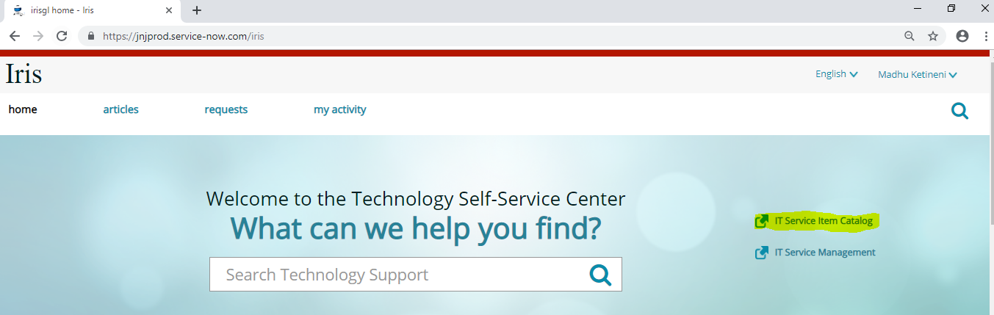

2. Select the tab “**Submit a request**” and click on “**Server provisioning and support**”

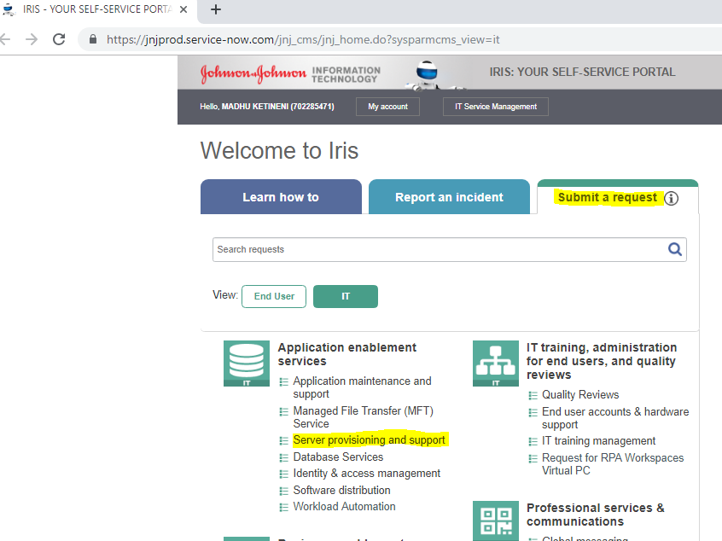

3. Click on “**Server Change and Maintenance**”

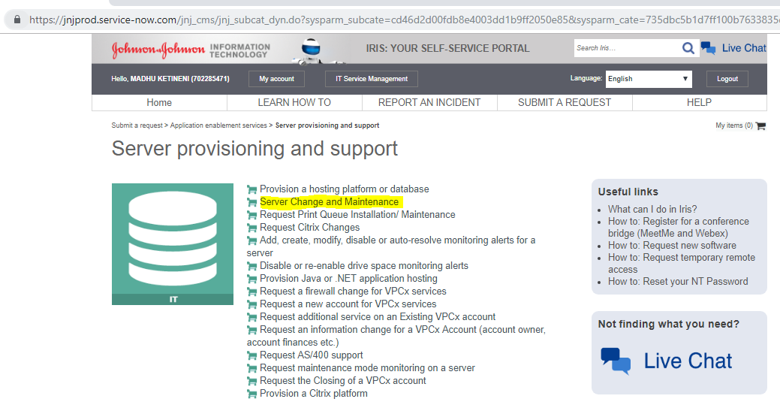

**4. Select or enter the required information on the next screen as shown below.**

* Select appropriate application associated with the server under “Select Application / Application Server”.
* Select the server on which the change/maintenance is required under “Select Server”.
* For Type of Activity select “File System – Add, Remove or Change”.
* Select Maintenance start and end timing.
* In Business Reason (Justification) enter the file systems to be created.
* Enter Technical Impact.
* Select appropriate Business Impact.

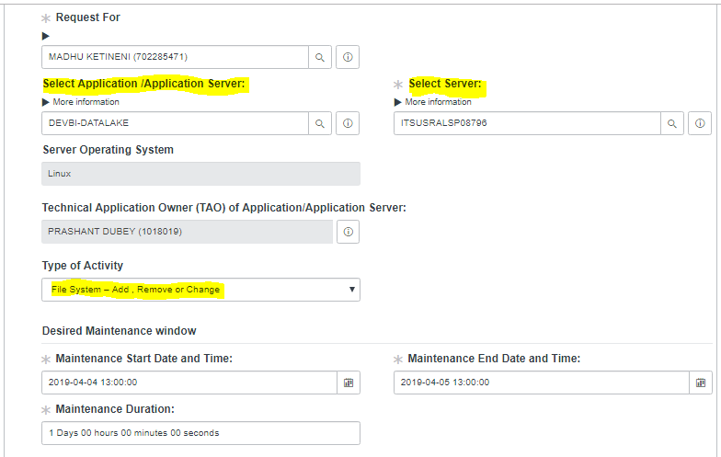

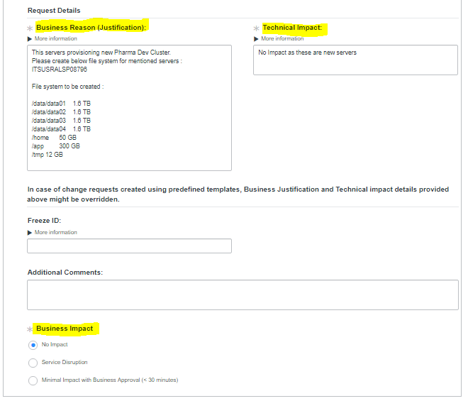

5. Click on “**Choose Options**” on the top right side of the screen

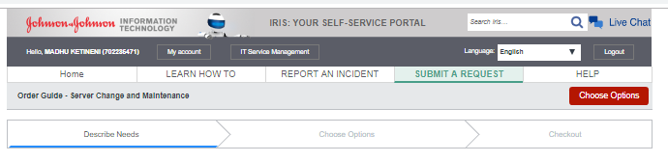

**6.** On the following screen select “**Create**” for “Type of Action” and in the table that will appear enter all the required details. Click on the Green **+** to get more rows.

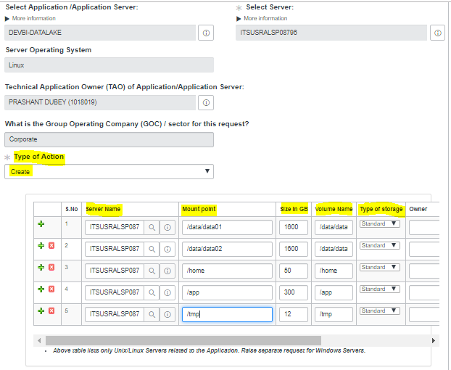

7. Click on “**Checkout**” on the top right side of the screen and the request will be submitted. Note down the Request number for reference.

